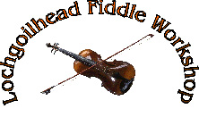
Graham MacKenzie
Mixed Instrument Workshop

STRACHUR MEMORIAL HALL
Strachur PA27 8DG

Saturday 9th JULY 2016
11am – 4pm

Registered Scottish Charity No.SC033935

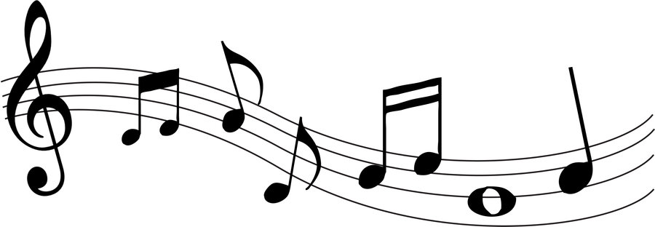

APPLICATION FORM

Name;

Address, including post code:

Contact Tel no:

Email address:

Instrument/s & Ability:

Cost of workshop will be £20.00 Spaces limited. Book early to avoid disappointment.

Please return completed form, with payment, by Friday, 1st July 2016 to
Treasurer
Glendarg
8 Lettersway
Strachur
Argyll PA27 8DP

Cheques payable to Lochgoilhead Fiddle Workshop

Registration 10.30am – 10.45am

Please bring packed lunch, tea and coffee provided.

